Regulations:
A14

H.T No

Sreenidhi Institute of Science and Technology
(An Autonomous Institution)
Code No: 4B202 Date: 29-Jan-2020 (FN)

B.Tech I-Year II-Semester External Examination, Jan/Feb-2020 (Supplementary)
Engineering Drawing – II (Common to All)

Time: 3 Hours Max.Marks:70

Note: a) No additional answer sheets will be provided.
b) All sub-parts of a question must be answered at one place only, otherwise it will not be valued.
c) Missing data can be assumed suitably.

Part - A Max.Marks:20

Answer all QUESTIONS.

1. | On a map, the distance between two places 5 km apart is 1 cm. Calculate the Representative Fraction. | [2M]
2. | Explain the difference between forward and backward vernier scales. | [2M]
3. | Draw the isometric view of cylinder of diameter 25 mm and height 50 mm when it is resting on HP | [2M]
4. | Draw the development of a square prism of side of base 30mm and height 50mm | [2M]
5. | Draw the development of a cylinder of diameter 40mm and height 20mm | [2M]
6. | Draw the isometric view of rectangle of sides 45 mm and 35 mm when it is vertical. | [2M]
7. | Explain about two methods of perspective projection | [2M]
8. | 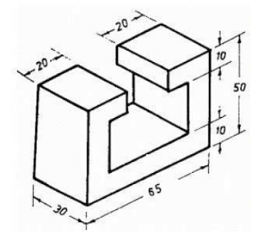  Draw the front view for the diagram shown in figure. | [2M]
9. | What are the advantages of computer aided drafting | [2M]
10. | What is the difference between cartesian and polar coordinate systems | [2M]

Part – B Max.Marks:50
ANSWER ANY FIVE QUESTIONS. EACH QUESTION CARRIES 10 MARKS.

11. |  | The area of a field is 50,000 sq m. The length and the breadth of the field, on the map is 10 cm and 8 cm respectively. Construct a diagonal scale which can read upto one metre. Mark the length of 235 metre on the scale. What is the R.F. of the scale? | [10M]
12. |  | Construct a full-size vernier scale of inches and show on it lengths 3.67", 1.54" and 0.48". | [10M]
13. |  | A cone of base 50 mm diameter and height 65 mm rests with its base on H.P. A section plane perpendicular to V.P and inclined at 30o to H.P bisects the axis of the cone. Draw the development of the lateral surface of the truncated cone. | [10M]
14. |  | Draw the front view , top view for the diagram shown in figure.  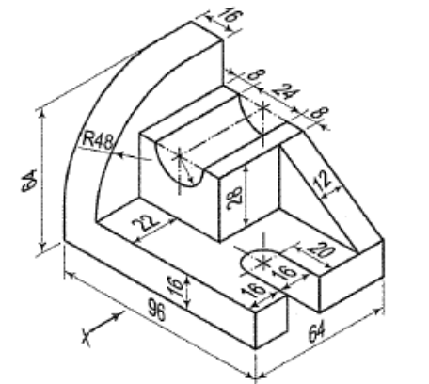 | [10M]
15. |  | For the orthographic views shown in figure, draw the isometric view  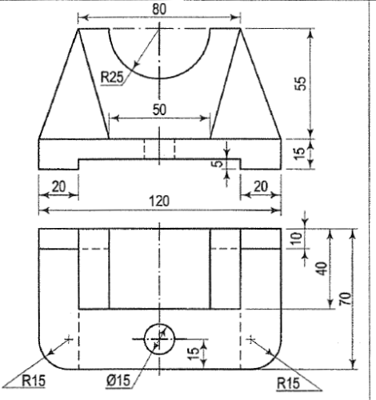 | [10M]
16. |  | 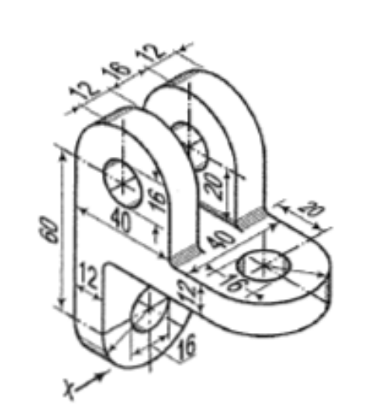  Draw the front view , top view for the diagram shown in figure. | [10M]
17. |  | A rectangular pyramid, base 30 mm x 20 mrn and axis 35 mm long, is placed on the ground plane on its base, with the longer edge of the base parallel to and 30 mm behind the picture plane. The central plane is 30 mm to the left of the apex and the station point is 50 mm in front of the picture plane and 25 mm above the ground plane. Draw the perspective view of p | [10M]
18. |  | Explain about the following  - different methods of dimensioning in CAD packages  (ii)Different options for drawing circle in CAD packages | [10M]
-- 00 -- 00 –

